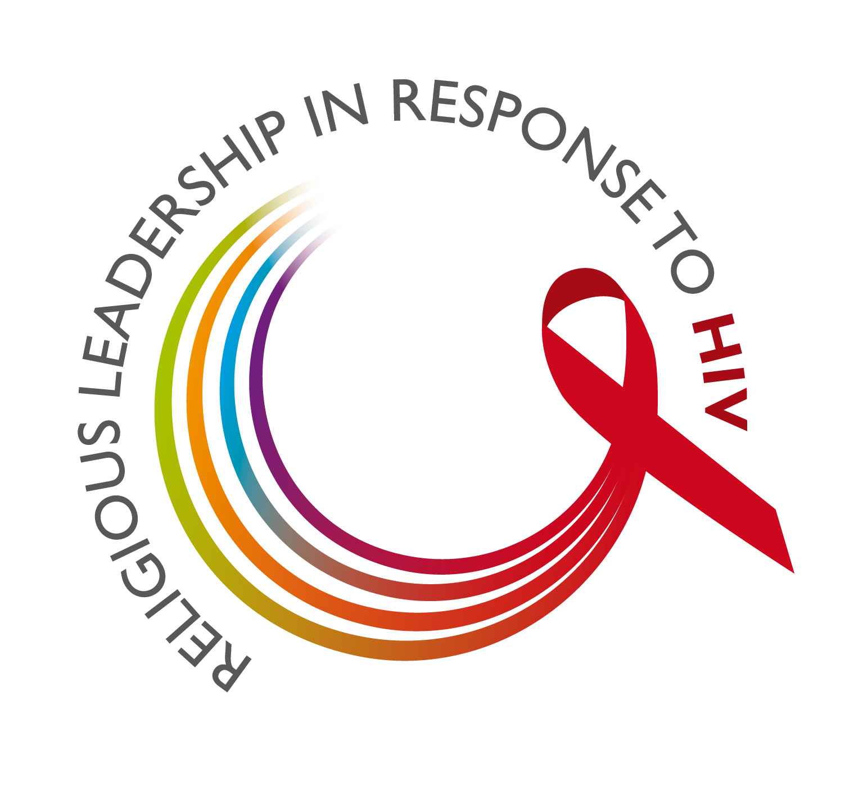

“Together We Must Do More”

How I Have Fulfilled
My Personal Commitment

Name:

Faith community/organization:

Country:

Email address:

What have I done?
(remember, the commitment has sections on people living with HIV; children; young people; women and girls; men and boys; my religious community; networks, organizations and public institutions.)

What challenges have I encountered?

What difference have my actions made to me, to the people and community I serve?

What lessons, observations, recommendations would I share with other religious leaders who have signed the personal commitment?

Web links to stories or reports on the actions mentioned above:

Please attach relevant documents (Word files, PDFs, photos, video, etc.)

If submitted on behalf of the religious leader:

Submitted by (name):

Email Address:

What will we do with this information?
These stories and reports will be compiled and shared with those who have signed the personal commitment. The multifaith working group following up on the Summit of High Level Religious Leaders (March 2010) will meet with a small group of religious leaders at the end of November to assess the fulfillment of the personal commitment and make recommendations for the next period (until March 2013).

For more information, please contact: Anne-Laure Jan at Anne_Laure.Jan@eaamail.ch

